Module 7:

Assigning and Leveling Work Resources

Contents

Module Overview 1

Lesson 1: Overview of Assignments 2

Review of Task Types and Effort-Driven Scheduling 3

What is an Assignment? 6

Assignment Formula 7

Lesson 2: Creating Assignments 12

Creating Fixed Unit Assignments 13

Creating Fixed Duration Assignments 18

Creating Fixed Work Tasks 21

Manual VS. Automatic Scheduling Assignments 23

Practice: Creating Assignments 26

Lesson 3: Factors that Affect Assignments 27

Percentage Assignments 28

Delaying an Assignment 31

Resource Calendar 33

Max Units 36

Best Practices and Rules for Creating Assignments 38

Practice: Working with Factors that Affect Assignments 42

Lesson 4: Viewing Resource Assignments 43

Resource Usage View 44

Task Usage View 48

Team Planner View 50

Practice: Viewing Resource Assignments 55

Lesson 5: Resolving Resource Overallocations 56

Understanding Overallocations 57

Views to Identifying Overallocations 58

Leveling Resources Manually 62

Leveling Resources Automatically 64

Practice: Resolving Resource Overallocations 70

Summary 71

7

.

# Module Overview



The creation of resource work assignments is the basis of project scheduling and resource allocations. Creating assignments can also be a detailed and complicated process. Knowing what the resource scheduling goals for the project are will help simplify how resource assignments are created. This module explains how resource assignments are created, unique views for assignmend created and resource leveling.

At the completion of this module you will be able to:

1. Understand the concepts behind resource assignments
2. Understand scheduling formula
3. Create assignments for work resources
4. Use the views in Project 2010 used to see assignments
5. Leveling the work of resource assignments

# Lesson 1: Overview of Assignments



Understanding the concepts behind assignment creation will increase understanding of how assignments are formed. This lesson will help with understanding the scheduling theory, the calculations used during creating work assignments, and the software settings governing the assignments.

In the lesson we will cover:

1. Review of task typing and effort-driven concepts
2. What is an assignment?
3. The scheduling formula used by MS Project 2010

## Review of Task Types and Effort-Driven Scheduling



Understanding task types and effort-driven settings are essential to understanding how assignments are created. Earlier we discussed what these terms mean and it would be helpful to review them before we discuss creating work assignments.

**Effort-driven:** When 1 person moves 10 boxes it could take 5 minutes per box or 50 minutes total. However, if 5 people move the boxes, it would take less time (10 minutes) because the work is divided across the resources. In this case, all work is equal. As long as the boxes are all moved, which resource moves which box is not important. The key to remember with effort-driven scheduling is: the work is divided over the resources and the time required to complete the task is shortened.

Project 2010 allows for 3 task types for scheduling:

* **Fixed Duration:** A fixed duration task is a task created with a fixed length of time. Fixed Duration tasks are also tied to dates. Resources will only be assigned if available to work between the start and finish dates of the task.
* **Fixed Units:** Fixed Units is the quantity of resource assigned to a task and is the default task type. The quantity can be expressed in hours or a percentage of a whole resource. Fixed Units means that the resource assignment quantity is fixed for the task. Using this task type will result in the quantity of the units assigned to a task coupled with the availability of the resource to determine the duration of the task. If a task duration changes or if the amount of work changes, the resource units will not change for the task.
* **Fixed Work:** The work of the task is fixed. Fixed work tasks are always effort-driven by default. The more resources assigned to the task, the less time the task will take to be completed because the work is divided over the resources. Fixed work tasks will be scheduled based on the quantity of the units of resources assigned and availability as stated on their resource calendar.

When coupled with the effort-driven option, the scheduling engine allows for 5 combinations of task type, effort-driven settings:

* Fixed Duration, Effort-driven on
* Fixed Duration, Effort-driven off
* Fixed Units, Effort-driven on
* Fixed Units, Effort-driven off
* Fixed Work, Effort-driven on

To create effective resource scheduling assignments it is imperative that the task types and effect-driven settings for the tasks are correct. Different settings deliver different results during assignment creation. For this reason, understanding the work of a task is the best place to start. Once the work is understood, it will be much easier to choose an appropriate task type and resource types required to complete the task.

Inserting the Work, Effort-driven and Type columns into the Task Entry table will display all of the information in a single view to allow for proofreading and resetting of the values as needed.

To add the Work, Effort-driven and Type columns into the Task Entry table:

* **Tasks 🡪 Gantt Chart**
* Double Click the title of the start column
* Click the **W** key
* Select **Work**
* Double Click the title of the start column
* Click the **E** key
* Select **Effort-Driven**
* Double Click the title of the start column
* Click the **T** key
* Select **Type**

The resulting view is shown below:

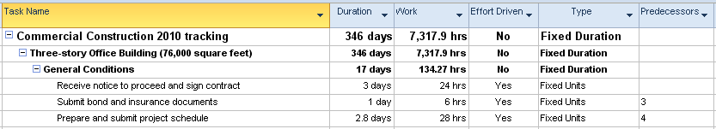

**Note:** *Summary tasks are always Fixed Duration and can not be changed.*

**Manually scheduled tasks vs. Automatic scheduled tasks:**

The scheduling engine ignores task type and effort-driven flags for manually scheduled tasks. These values apply only to automatically scheduled tasks.

If a task is changed from manual scheduling to automatic scheduling, the task type and effort-driven values become meaningful. The value for these fields will be picked up from the options default settings when the task is entered. These values should be rechecked when switching modes to ensure correctness.

## What is an Assignment?



The “what” of the project are the tasks which represent what work needs to be accomplished. The resources are the “who” or who will perform the work. The assignment is applying the resource to the task to create the “when” and for “how much ” (cost and time). How the assignment is created will result in different outcomes for the values in the assignment.The values used in creating the assignment will drive the result for the duration, work and quantity of the resource assigned to the task.

**Example**: A task, “Paint the room” is estimated to take 3 days at 8 hours per day. The task type is Fixed Units, effort-driven off and 1 painter has a rate of $30 per hour.

The result of this assignment is:

24 hours of work for 1 painter to be completed over 3 days. The resource was applied to the task at 100% units and has full availability during the dates the task is planned.

As a result of the assignment, we now have the “when”, which is the schedule dates of the task. We also have the “how much” which is 24 hours of work at $30 per hour or a cost of $720 to complete the task.

If the task had been scheduled using 3 available painters to work at the same time and rate, the assignment outcome would be different:

The task would change to an effort-driven task. Each of the 3 painters will work 8 hours to complete the 24 hours of total work. They would each be scheduled for 1 day of work and the cost would remain at $720. The task now completes in 1 day’s time and 2 days earlier.

## Assignment Formula



The assignment formula contains 3 parts. Each part can be defined separately to best reflect the needs of the task. Determine on a task by task basis which pieces of information are required and which pieces should be calculated.

The 3 pieces of information are: Duration, Work and Units

The formulas are:

* Units = Work / Duration
* Duration = Work / Units
* Work = Duration x Units

Units are defined as the quantity of a resource.

* 1 or 100% = 1 full person
* .5 or 50% = ½ of a person

Assignment unit values are represented as a percentage or decimal formats. The setting is a personal preference. The setting can be switched back and forth without consequence to the assignments.

To set assignment units view preference:

**File 🡪 Options 🡪 Schedule**

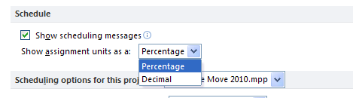

Below are some examples of resource assignment calculations. In all examples it is assumed that 1 day is 8 hours and resources have full availability on their calendars.

**If Duration and Work are entered Project 2010 will calculate *Units***

Example: Task duration is 10 days and the work is 400 hours  
 Each person can work 80 hours within 10 days   
 Project 2010 will calculate 400 hours in assigning  
 5 people to perform and complete the work in 10 days.   
 400 hours of work / 10 days = 5 units (100%)

This example answers the following question: How many people, working 8 hours per day, will it take to complete the task in 10 days? The answer is 5 people.

**If Work and Units are entered Project 2010 will calculate the *Duration***

Example: Work required is 400 hours and Units is 10 full time people (FTE)  
 Each person can work 40 hours per week   
 The duration calculation is 5 days

400 hours / 10 units (100%) = 5 days duration

This example answers the following question: How long will it take 10 people, working 8 hours per day to complete 400 hours of work? The answer is 5 days.

**If Duration and Units are entered Project 2010 will calculate *Work***

For example: Duration is 5 days and Units is 10 full time people  
 each person can work 40 hours per week.   
 The work would calculate to be 400 hours.

5 days x 10 people at 40 hours per week = 400 hours

The example answers the following question: How many hours of total work will result if there are 10 people who work 8 hours per day for 5 days? The answer is 400 hours.

Resources might not be available to work full time on tasks. The examples below will calculate the examples with the resources available at 50% of their availability. In all examples it is assumed that 1 day is 8 hours and resources have full availability on their calendars.

A *fixed unit* task which is scheduled for 5 days and 40 hours of work.

* If the task is effort-driven off and 1 resource is assigned 100% to the task:   
   Result: 40 hours of work to be completed in 5 days.
* If the task is effort-driven off and 1resource is assigned 50% to the task:   
   Result: 40 hours of work to be completed in 10 days.
* If the task is effort-driven off and 2 resources are assigned 100% to the task:   
   Result: 80 hours of work to be completed in 5 days.
* If the task is effort-driven on and 2 resources are assigned at 100% to the task:  
   Result: 40 hours of work to be completed in 2.5 days. Each resource will   
   work 20 hours full time
* If the task is effort-driven on and 2 resource are assigned at 50% to the task:  
   Result: 40 hours of work to be completed in 5 days. Each resource will   
   work 20 hours half time (4 hours per day)

The above assignments were created with the assumption that the resources were available during the scheduled times. If the resources are not available, the duration of the task for Fixed Unit and Fixed Work tasks will increase and the work will be scheduled when the resource becomes available. Fixed duration tasks are tied to dates. Resources must have availability between the dates of the task or the task might change duration to accommodate the resource availability. When scheduling a resource without availability between dates for a fixed duration task, the following error message will be returned.

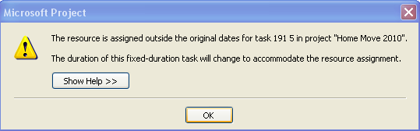

Calculations are very detailed and complex, and produce different results when any of the variables change. The chart below will help predict resulting changes to variables and provide an easy look-up table:

|  |  |  |
| --- | --- | --- |
| **Task Type** | **Modified Field** | **Field Recalculated** |
| Fixed units | Duration | Work |
| Fixed units | Units | Duration |
| Fixed units | Work | Duration |
| Fixed duration | Duration | Work |
| Fixed duration | Units | Work |
| Fixed duration | Work | Units |
| Fixed work | Duration | Units |
| Fixed work | Units | Duration |
| Fixed work | Work | Duration |

Below is a quick reference which will help with some of the nuances of assignments.

|  |  |  |
| --- | --- | --- |
| **Task type** | **Effort-Driven Setting** | **Field recalculated when adding or removing a source** |
| Fixed units | On | Duration will change as resources are added to share the work. Duration will be calculated based on number of additional resources, assignment units and availability calendar. |
| Fixed units | Off | More resources added, more work will occur. Duration will be calculated based on number of resources, assignment units and availability calendar. |
| Fixed duration | On | Work is shared in a limited time frame. |
| Fixed duration | Off | More resources added, more work will occur. |
| Fixed work | On always | Duration will be calculated based on number of resources, assignment units and availability calendar. |

**TIP:** *it is a good idea before assignments are created to save a copy the original values of the work and duration columns. If these columns are recalcuted during assignments they will not return to the original values if the assignments are removed.*

**To copy the duration column:**

* Right click on the Duration column heading
* Click on Insert Column
* Click the D key on the keyboard
* Select Duration1
* Right click on the column name Duration 1
* Select Field Settings
* Enter title: Original duration
* Click OK
* Click on the title for the Duration column to select the column
* Click Copy
* Paste in the Original Duration column.

**To copy the work column:**

* Right click on the Work column heading
* Click on Insert Column
* Click the T key on the keyboard
* Select a Text column 1 - 30 which is not used
* Right click on the column name Text (1-30)
* Select Field Settings
* Enter title: Original work
* Click OK
* Click on the title for the Work column to select the column
* Click Copy
* Paste in the Orignial Work column.

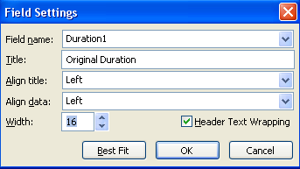

# Lesson 2: Creating Assignments



The most useful view to create assignments is the Task Entry view or Gantt Chart on top and the Task Form on the bottom of a split screen. The Task Form has multiple sub views that are very helpful when creating assignments. The views are Work, Cost and Schedule. It is also helpful to add the work column to the Task Entry table of the Gantt Chart.

**To display Task Entry view:**

* **Task 🡪 Gantt Chart 🡪 More views 🡪 Task Entry 🡪 Apply**
* Insert the **Work** column in the top pane
* Right click in the bottom pane and select **Work**  
    
  OR
* **Task 🡪 Gantt chart**
* Double click on the bar underneath the down arrow at the bottom of the scroll bar 
* Right click in the bottom pane and select **Work**

**NOTE:**  *Assignments may be made using the* ***Assi****gnment dial****og b****ox, Task Information dialog box or adding resources to the Resource Name column on the Task Entry table. Using the Task Entry view to assign resources allows the scheduler to see the work, schedule and duration results of the assignment.*

In this lesson you will learn to:

1. Create fixed unit assignments
2. Create fixed duration assignments
3. Create fixed work assignments

## Creating Fixed Unit Assignments



When creating fixed unit assignments, the amount or quantity of the resource assigned to the task is fixed and will not change.

**NOTE:** *in the examples below, the Resource Sheet entries for each resource are Max Units of 1 or 100% and $100 per hour is the Standard Rate. Each resource also has 8 hours per day on their availability calendar.*

Task assignments are best created in the Task Entry view. This is the only view where all of the information regarding the result of the assignment is available. If the results are not what is expected this view may also be used to make adjustments if necessary.

In the example below an automatic scheduled task called “Determine the best method of moving” is a fixed unit, effort-driven off task with a duration of 5 days. Work is zero and the original schedule dates are April 23-27, 2012. The view below shows the subview in the Task Form of Work.

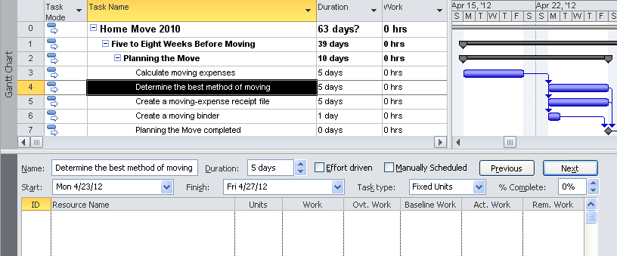

Click in the Resource Name area in the lower pane of the view and select a resource from the alphabetical list of resources. The button called “Previous” will change to “OK” and was clicked to enter the assignment. Note below the affect of this assignment. Larry Adams has been assigned to the task for 40 hours of work. There are no changes to the dates or duration of the task.

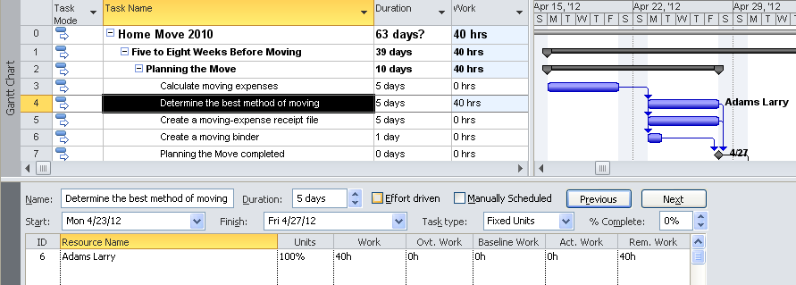

Assigning a second resource to the task will increase the hours to 80 hours and the duration is unchanged. There is an increased cost to the task for the additional 40 hours of work:

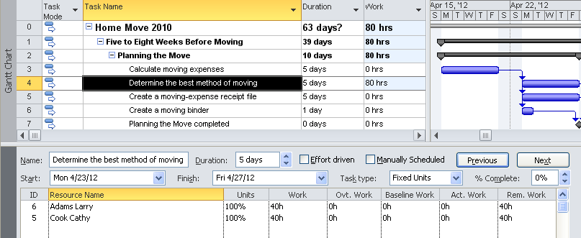

In the next example, the resources have removed from the assignment. An easy way to remove all resource assignments is to click on the top resource name and click the **Delete** key on the keyboard until the assignments are removed. Click **OK** to update.

In the example below the situation is exactly the same as the first example above except the effort-driven flag has been turned on. The first assignment has been created.

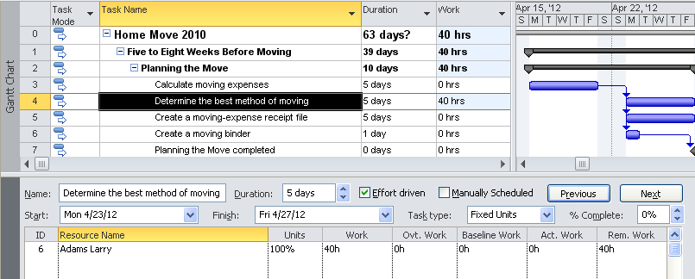

With only one resource, this assignment will look the same as the first example. Dates have not changed and the work is 40 hours. If a second resource is added, the total work of the task is 40 hours and will now be divided between the 2 resources assigned to the task. The task duration has been changed to 2.5 days from the original 5 days and the ending date is now April 25.

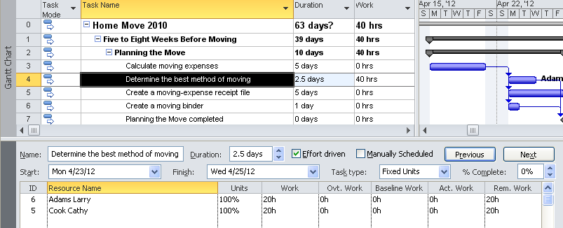

A third resource is assigned to the task. The work is again divided between 3 resources with each working 13.33 hours on the task. The task duration has again changed to 1.67 days and the task now ends on Tuesday, April 24. As additional resources are assigned to the task the work will continue to divide among the resources.

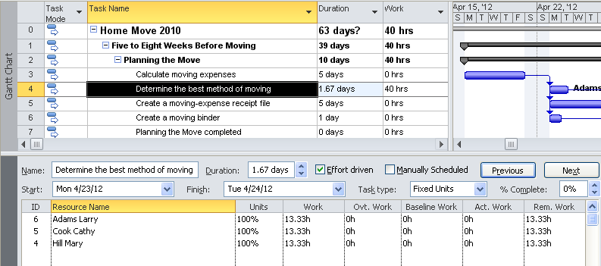

Multiple changes may be made in the Task Form and all changes will be updated when the **OK** button is clicked. This is usually not a concern for non-effort-driven tasks. However, for effort-driven tasks this will result in a difference in the amount of work assigned to a task. In the previous effort-driven task example, each resource was added one at a time clicking **OK** after each addition to update the assignment. In the example below, all resources were deleted. All 3 resources were added to the task and then the **OK** key was clicked and all 3 additions were updated simultaneously. 120 hours of work was calculated for the task for this example. The number of hours is calculated based on the first transaction. Subsequent transactions will divide the number of hours over all of the resources.

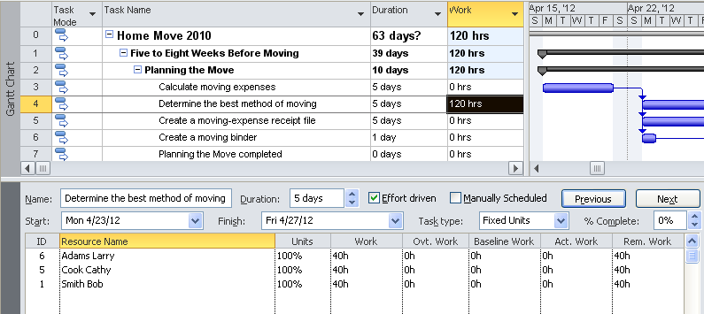

Care needs to be taken in creating effort-driven assignments as they could have a substantial impact on resource allocations and cost estimates for a project. Using other assignment views will not allow the scheduler to see the results of an assignment.

If the automatic calculation for an assignment returns an incorrect hours result for a task, do not hestiate to enter the number of work hours for a resource to correct the values. Click **OK** to update the changes.

Right clicking in the Task Form in the bottom pane will return options to see the assignment using other views. The Cost and Schedule views are very helpful to see the resource costs or dates when tasks are scheduled.

**Group assignments:**  To create assignments for more than one resource within a group, increase the value in the unit’s column.

**Example:**  3 Helpdesk workers are needed to work for 5 days (40 hours each). Enter 3 in the units field in the Work view. The result will be 3 people will provide a total of 120 hours of Helpdesk labor for the task.

**Generic resources:** When the actual resource is not known, assign a skill type or generic resource to a task as a holding value. Using a generic resource will create the demand for the resource and add an estimated cost to the project schedule. When the human resource is acquired, substitute the human resource name for the generic name on the Resource Sheet and all assignments will transfer to the human resource.

**NOTE:**  *When using generic resources, the default base calendar is used to schedule the resource. When a human resource is substituted for a generic resource and their availability is taken into consideration, there is a high probability that the tasks will lengthen. As a rule of thumb, projects could double in length when human resources are substituted for generic resources.*

## Creating Fixed Duration Assignments



Fixed duration task assignments have a fixed length of time. The amount of work that is accomplished between the task dates will be dependent upon the number of resources assigned to a task, number of resource units and the availability of the resources.

The following examples will continue to use the Task Entry view with the Work subview in the lower pane. In the example below, the *automatic* scheduled task “Verify that your belongings are insured for the move” will take 5 days to accomplish. This example is fixed duration, effort-driven off. The assigned dates are May 1 to May 7. The dates span more than 5 days because it crosses over non-working weekend days. There are also zero hours of work entered for the task.

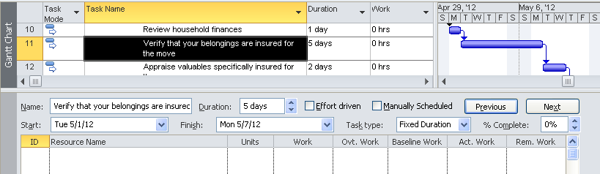

When one resource is assigned to the task the duration will remain the same and the work is increased to 40 hours. Note the work and duration in the view below.

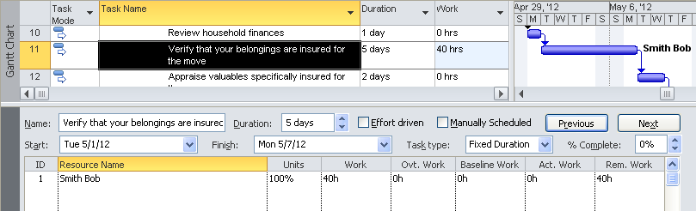

When an additional resources are added, the duration remains the same and the work increases again. The three assignments result in 120 hours of work for the task. The dates have not changed.

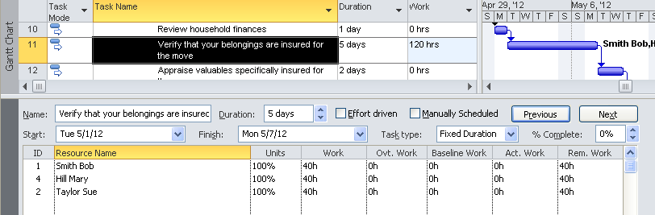

In the following example, all 3 resources have removed and the task type effort-driven flag has been turned on. One resource was then assigned to the task.

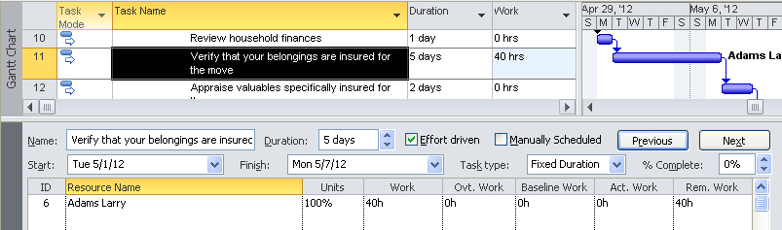

In the example below 2 more resources were added to the task. The task remains at 5 days duration and the work also remained at 40 hours. The work was divided between the resources. In this example, the resources were assigned one at a time.

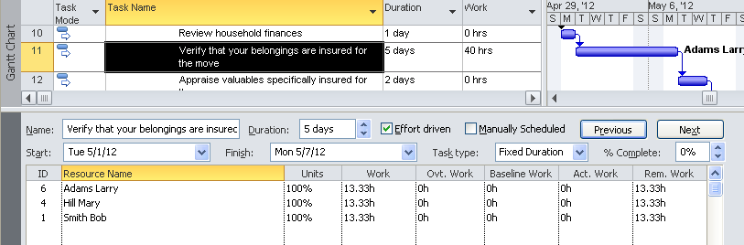

In the example below, the resources were removed and all 3 resources were assigned at the same time. The 3 names were selected and then OK was clicked. Note that each resource is assigned at 100% to the task. The total amount of work is 120 hours and will carry a higher cost due to the increased hours. Any additional resources assigned to this task will take a portion of the original 120 hours.

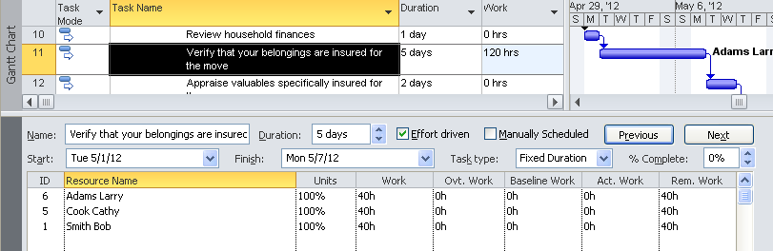

## Creating Fixed Work Tasks



Fixed work tasks are tasks where the value entered in the work column is a fixed value for the task. Duration is always calculated based on the number of resource units assigned to the task and the status of resource availability.

The following examples continue to use the Task entry view with the subview Work. In the example below, the automatic scheduled task “Pack the boxes” is estimated at 200 hours of work. It is also a fixed work task which is always effort-driven. Notice that the task duration is 1 day. Since the duration is always calculated for a fixed work task, the value in the duration field is not important.

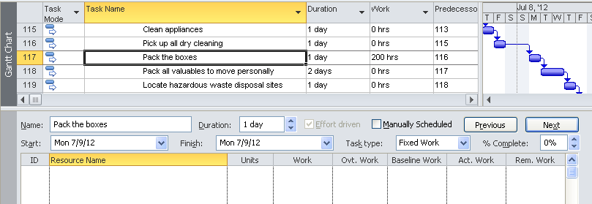

In the example below, 1 resource has been assigned to “Pack the boxes”. As a result, Eric will be assigned to work for 25 days at 8 hours a day packing boxes.

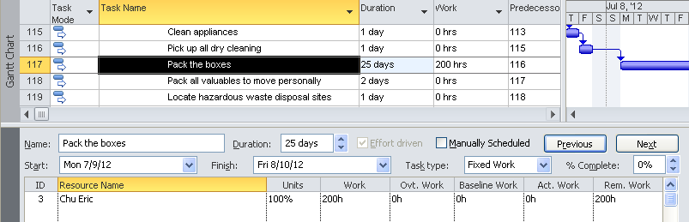

In the example below Eric has been given 2 people to help him with this task. The task will now take 8.33 business days to accomplish the work with each resource working 66.67 hours on this task. The work for the task has not changed. It does not make a difference whether all resources are assigned at one time or individually.

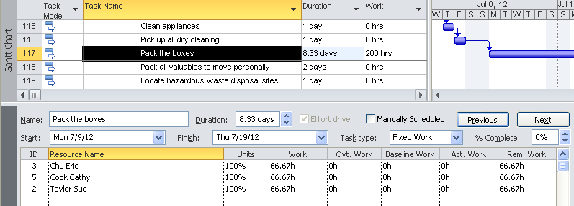

## Manual VS. Automatic Scheduling Assignments



Automatic scheduled tasks use Project 2010’s scheduling engine to calculate work, duration and cost for tasks. Manual scheduled tasks, however, are not using this calculation. New fields have been added to Project 2010 for manually scheduled tasks which determine the start and finish dates for the tasks. The fields are:

* **Scheduled Start** - Start, Finish and Duration are optional for manually scheduled tasks, read only field
* **Scheduled Finish** – Start date recommended by Project 2010, read only field
* **Scheduled Duration** - a entered duration or value calculated by Project 2010, read only field

When assignments are created for manually scheduled tasks, only the duration field is part of the calculation and work is not considered. The assignment will also use the availability of the resources as well as the assignment unit to calculate the assignment.

In the first example below, the fixed work task is using automatic scheduling mode. 1 resource is assigned to a task that has 200 hours of work. The value in the duration column before the resource was assigned was 1. The resulting calculation is, 25 days of work to pack boxes using a single resource.

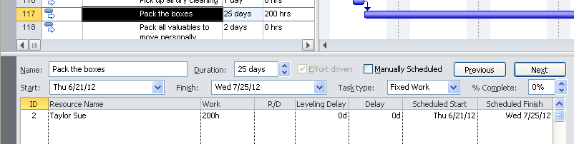

Below is the same task using manual scheduling mode. Before the assignment was made, duration was 1 day and work was 200 hours. The scheduled duration column is the value used to schedule the task in manual mode. Notice how the work value was changed to 8 hours of work from the original 200 hours. Only 8 hours of work are now schedule for this task.

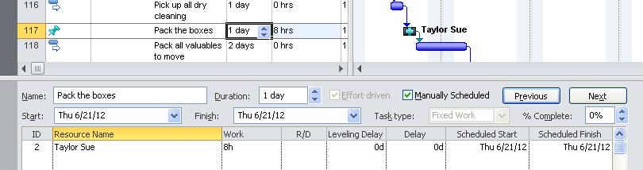

Below is the same task in manual schedule mode with 25 days entered in the duration column. Note that the work is now estimated to be 200 hours.

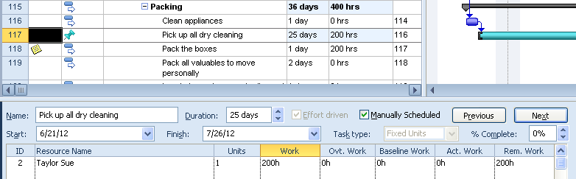

In this last example, the duration column has text and zero hours of work when the resource assigned was entered.

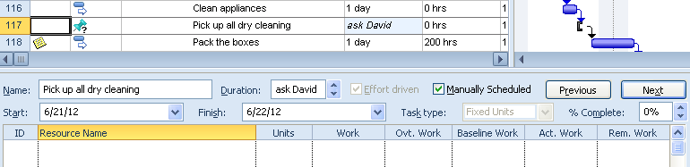

The result of assigning 1 resource to the task is shown below. The duration retained the orginal text value and work increased to 8 hours because the resource was assigned using the units value of 1. If the units value used had been 2, 16 hours would have been calculated.

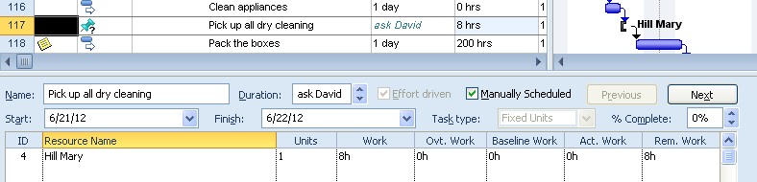

## Practice: Creating Assignments



*The Practice page is where you write detailed instructions for completing work listed as Exercises.*

*Type the Exercise Title and write a brief summary what the student will be doing in the exercise. Then list your ideas what they will be doing.*

*SAMPLE*

*In this practice you will create a Project Server Authentication profile and then configure the local cache settings in Project Professional 2007.*

*Exercise 1: Create Project Server Authentication Profile*

*In this exercise you will create Project Server authentication profile to connect to the Project Web Access site.*

Perform the following exercise on the PS07 virtual machine.

1. *From the* ***Start*** *menu, click* ***All Programs*** *🡪* ***Microsoft Office*** *🡪* ***Microsoft Office Tools*** *and click* ***Microsoft Office Project Server 2007 Accounts****.*
2. *In the* ***Project Server Accounts*** *dialog box, click* ***Add****.*
3. *In the* ***Account Properties*** *dialog box, and complete the following settings and click* ***OK****.*

|  |  |
| --- | --- |
| *Setting* | *Perform the following:* |
|  | |
| *Account Name* | *Type* ***Project Server*** |
| *Project Server URL* | *Type* ***http://epm/pwa*** |
| *When connecting* | *Select* ***Use Windows user account*** |
| *Set as default account* | *Select check box* |

# Lesson 3: Factors that Affect Assignments



In the previous lesson, we discussed the concepts of creating work assignments. Assignments will include more nuances and concerns involved in developing a realistic project schedule. This lesson will address a variety of variables that should be considered while creating resource assignments.

In this lesson we will discuss:

1. Percentage assignments
2. How the resource calendar will influence assignments
3. How to delay an assignment
4. How Max. Units affects an assignment
5. Best Practices for creating assignments

## Percentage Assignments



Resources typically are not available to work full time on a task. To accommodate this need, percentage assignments may be created. The percentage will be a percentage of the time that a resource has available on their calendar.

For example: A resource has 50% availability of their time to work on a given task. If the resources workday is 8 hours per day on their resource calendar, the assignment will result in 4 hours per day of work time on the task.

In the example below a resource has been assigned 50% to a 5 day, fixed unit task. The resource has 8 hours per day available on her resource calendar. Since she is assigned at 50% units, she will is assigned to 20 hours of work or 4 hours per day during the 5 days. The work column did not have a value entered when the assignment was created.

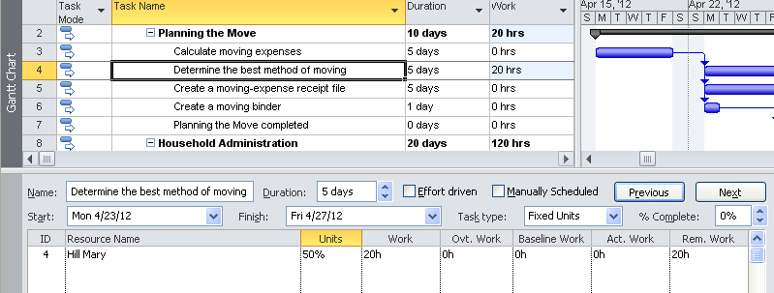

In the next example, the resource was removed from the task. 40 hours was entered in the work column stating that the task will require 40 hours to complete. 5 days was left in the duration column and the 50% assignment was recreated.

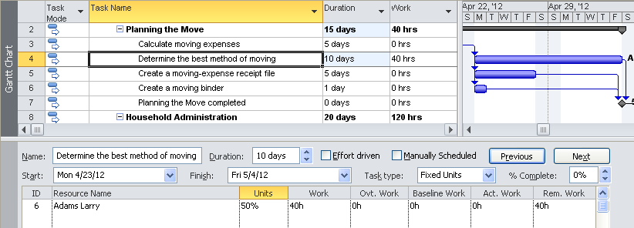

In the example below, the 40 hour task has a resource assigned at 50% units and the duration of the task was recalculated to 10 days. The resource is available to work 4 hours per day or 20 hours per week and it will take 10 days to complete the task. If the resource had been unavailable during the 10 day time period, the task duration would have increased to accommodate the unavailable time.

In the Resource Usage view below, the resource detail is on the top which shows that Larry   
Adams will work 4 hours per day for the length of the task. In the Task View below the Schedule view shows the start and end dates for the assignment.

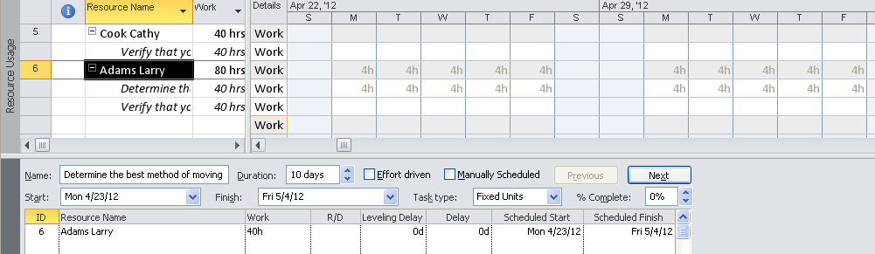

This view may also be used to fine tune assignments. Hours may be entered per day to contour the assignement. There is also an automatic contour function available. By double clicking on the assignment (not the resource name), the assignment information box will appear. Work contour has several options: flat (default), back loaded, front loaded, early peak, late peak, turtle, and bell. Each of these will produce a slightly different work distribution for a task. Task dates might be moved to accommodate the contour.

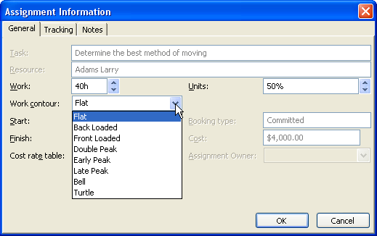

Below is the same assignment with the front loaded contour applied. When a contour is applied to an assignment, an icon will appear in the indicator column. Many of the contour options will also result in a longer duration for the task. The task below is now scheduled to finish on May 15.

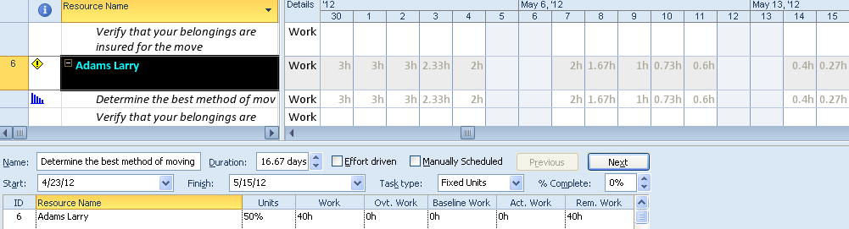

## Delaying an Assignment



If a resource is not available during the performance of a task the work of the resource might be delayed. If the resource is one of many on the task, do all of the resources have to work together or can resources perform their work separately? Entering a delay will affect the assignment of one resource and will not affect the other assignments on the task. If the entire task is delayed, all resources assigned to the task will be affected.

To delay the assignment for the one resource, use the Task Form🡪 Schedule view. In the example below, 3 resources are assigned to the task “Packing boxes” which is occurs May 17-29. Mary Hill has been asked to work on another task and cannot start her part of this task until the following Monday, May 21. She will need a 2 day delay in the start of her assignment.

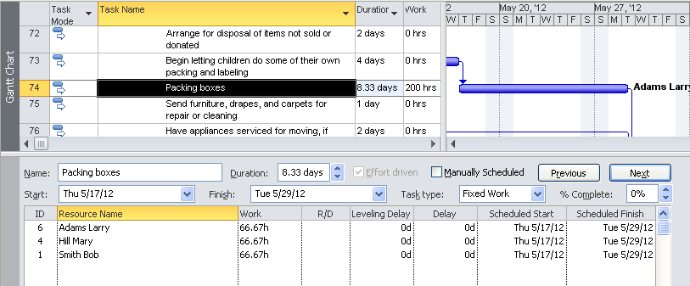

After entering the 2 day delay for Mary Hill, her assignment dates are May 21-31. This will result in the task taking 2 days longer and might also affect the end date for the project. Note that the delay affected the assignment of Mary Hill only and not the other resources.

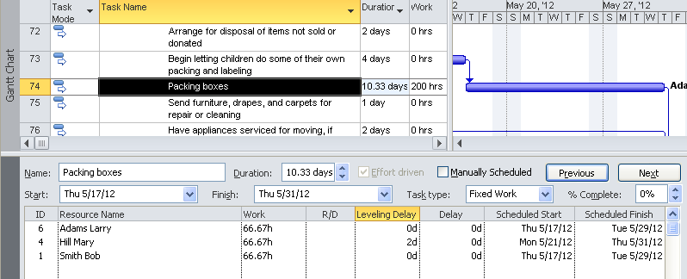

All delays will stay with the assignments until they are manually removed.

## Resource Calendar



All assignments are created with the availability of the resource in mind. If the resource is not available, the task will be delayed until the resource becomes available.

In the example below the resource is scheduled to “Determine the best method of moving” which should take 5 days starting on April 23 and ending on April 27.

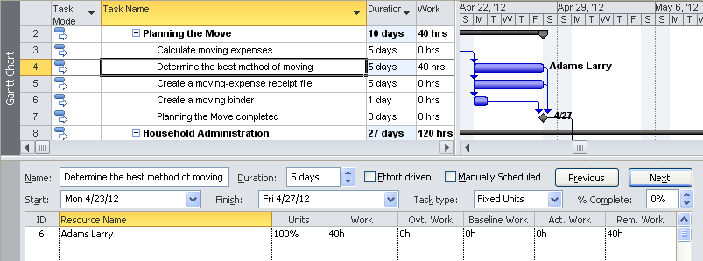

Larry Adams becomes unavailable for last 2 days of this assignment. The easiest adjustment would be to update Larry’s resource calendar with an availability change. The easiest way to access to the calendar is to double click on the resource name in the Task Form. As a result the Resource Information dialog box will appear and the calendar change may be made.

* Click on the **General** tab
* Click on **Change Working Time**

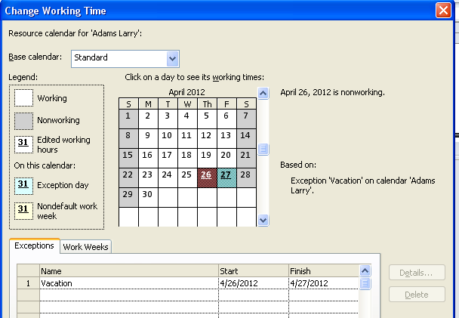

In the view below, the Resource Usage in the top view shows how the task is actually scheduled for this resource. The Task Form, Schedule view on the bottom shows the changed dates for the task assignment. April 26 & 27 have been deemed non-working days.

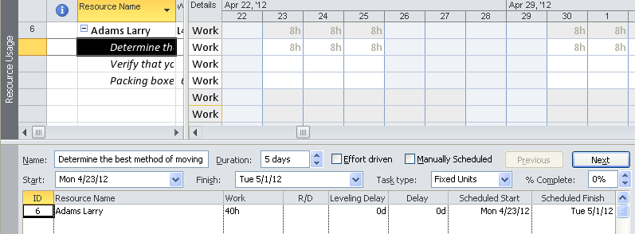

**Resource Availability and Fixed Duration Tasks:**

When a resource is assigned to a fixed duration task, the resource must have availability between the start and finish dates of the task. In the example below, when Larry Adams was assigned to a 5 day fixed duration task, he was assigned for 24 hours of work because he is available for only 3 of the 5 days required.

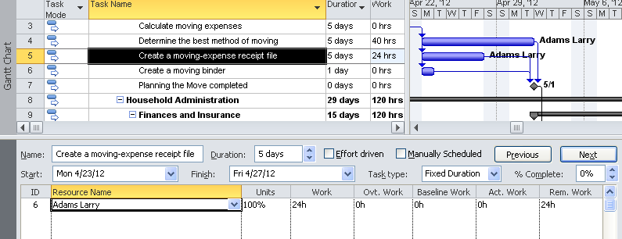

Below, the detail of the assignment is shown using the Resource Usage view.

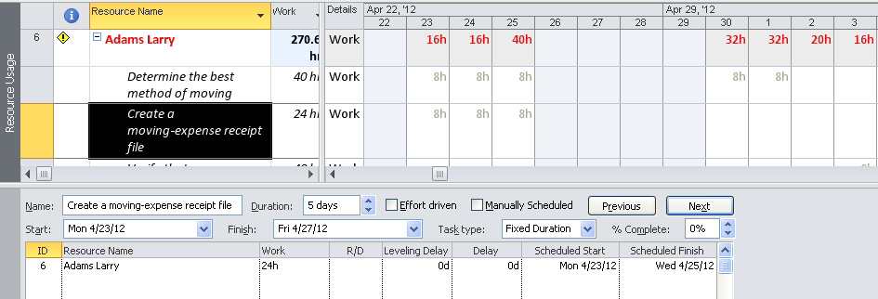

If a resource is assigned to a fixed duration task and the availability changes AFTER the assignment has been made, the following error message will be displayed.

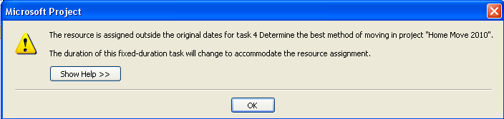

## Max Units



The Max units column on the Resource Sheet indicates the quantity of the resource that is available to be assigned to tasks. The Max units column displays the value as either a decimal or percentage format as determined in the scheduling options for the project. The display in decimal or percentage value is a personal preference and will not affect scheduling assignments.

For example:

* **If Max units is 100% or 1**: the default assignment would be at 100% of time that is available represented on the resource calendar for the resource.
* **If Max units is 50% or .5**: the default assignment would be at 50% of time that is available represented on the resource calendar for the resource.
* **If Max units is 500% or 5**: you will have up to 5 full time resources available to assign to tasks of this type of resource.

When creating percentage assignments, the assignment is a request for part of the availability of a resource. If the Max Units column is less than 1 or 100%, the result will be a percent of a percentage available for a resource. Since resource names do not indicate the value of the Max Units column, assignment results might not be consistent.

|  |  |  |  |
| --- | --- | --- | --- |
| Max units | Hours Available | Assignment percentage | Result |
| 1 or 100% | 8 | 100% | 8 hours |
| 1 or 100% | 8 | 50% | 4 hours |
| .5 or 50% | 8 | 100% | 4 hours |
| .5 or 50% | 8 | 50% | 2 hours |

**Max units and Fixed duration tasks:**

A status meeting would be a fixed duration, effort-driven off task. Mike is a 75% resource based on his Max unit setting. Joan is 50% and Ron is 25%. The project manager has 100% in his Max Units field.

The example below shows the result of each resource assignment to the task using their default settings. All attendees are required to attend for the entire 2 hours. To have this assignment work for each resource, 100% units should have been entered for each resource.

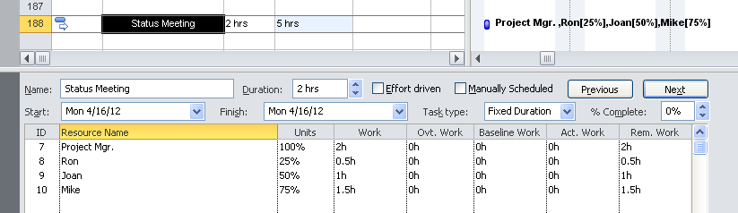

If the assignment was made from the Assignment dialog box, the Task Information box or by adding resource names on the task entry resource column, the details of the assignment would not be viewed. Use of Max unit percentage values for assignments should have a double check to make sure the outcomes are as expected.

**TIP:**  *Another way of handling limited availability of a resource is to limit the amount of available time on the resource calendars. This will allow uniqueness per resource and well as increased consistency in the treatment of resource assignments.*

## Best Practices and Rules for Creating Assignments



**Project 2010 software rules for creating assignments:**

* When work or duration values are recalculated, if the resources are removed, these values will not return to the original values.
* Generic resources will use the default standard calendar to schedule work, unless another calendar has been assigned to the resource. When a human resource is assigned, the task will most likely increase in length (except for Fixed duration tasks) to accommodate the availability calendar of the resource. This might result in an later scheduled project finish date.
* When assigning resources to a task using a task calendar, make sure that the option to “ignore the resource calendars” is checked. If this is not checked, the task will appear that the resources are assigned but the work values will be zero.
* Fixed duration tasks are tied to dates. When an assignment is created, the resource must have availability between the dates of the task. It is always a good idea to check the assigned work for the assignment. If the resource becomes unavailable after the assignment is made, the task length will change to accommodate the assignment.
* Manual v. Automatic scheduling task modes will return different assignment results. Switching from one mode to another might recalculate the work or duration of the task. Manual mode uses the duration value, resource availability and units to calculate assignments.
* When assigning work to Effort-driven tasks, the first assignment will establish the amount of work for the task. Other resources added after the first assignment will distribute the work of the task across the resources.
* Resources may have their availability limited by the resource availability ranges that are stored in the Resource Information box. (see below). To create a valid resource assignment, the task must occur within a timeframe that the resource is available.   
    
    
  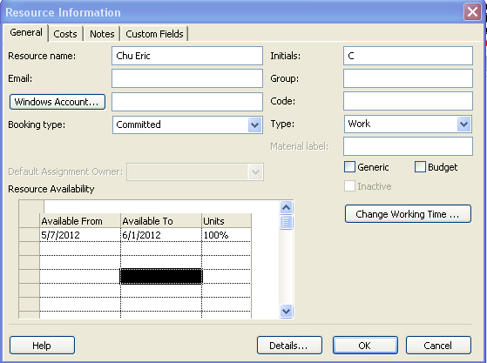  
    
  Below is a view of a task that is scheduled to start on April 16, 2012. The task does not have a resource assigned.

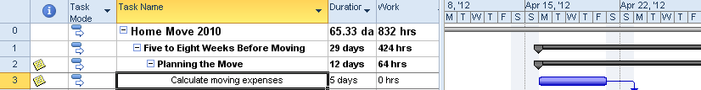

Below is a view of the same task with the resource assigned who is not available on the dates of the task because of the limitation of the resource date ranges. As a result, the task has been changed to a milestone task and no work has been assigned to the resource.

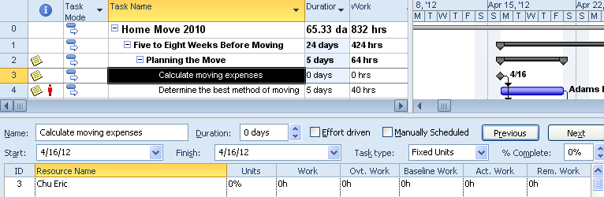

Best Practices for creating assignments:

* Double check task type and effort-driven flag before creating an assignment to make sure the settings are correct for the task. Double check these settings when switching from manual scheduling to automatic scheduling.
* Assignments are based on resource availability. The more accurate the resource calendars are, the more accurate the assignments will be.
* Use the Resource Usage view to refine the assignment of hours. Contouring is available.
* Use the Task Entry view. Gantt chart or Task sheet on top and Task Form or Detail task form on the bottom when creating assignments. Use the subviews of work, schedule and cost in the bottom pane. These are helpful views to use to check assignments for correctness.
* Do not assign resources to summary tasks or milestones. The software allows assignments to summary tasks, but summary tasks are subtotals and not trackable. Tracking will only be correct for Summary tasks when 0% work has been performed or 100% of the detail tasks for the summary task are completed. Milestones are 0 work and 0 duration tasks. Assigning a resource changes the meaning.
* Understand what the work of the task is before creating the assignment. Having this understanding will help in knowing if the assignment is correct for the task.
* Assign resources one at a time, at first to become comfortable with creating assignments. Assign multiples as your comfort level increases. Remember, when assigning resources to effort-driven tasks, the way the resources are assigned can result in different work and cost values for the task.
* If you are having problems calculating the correct number of hours of work when creating assignments, do not hesitate to enter the number of hours per resource for a task.
* If the assignment gets confusing, remove all resources and start over.
* Do not change task type mid-assignment. If you feel the task type should be changed, remove the resources, change the task type and reapply the resources.
* Most project managers do not feel that resources produce 8 hours of project work in a day. If assignments are created at 8 hours per day, are you are likely creating an unrealistic schedule. Many project managers will use 75% to 80% of an 8 hour day when assigning resources at 100% availability.
* If you are assigned a resource for 50% of their time, clarify how many hours of work per day 50% represents. Does 50% mean 50% of his total work time or 50% of the time the resource has available to work on projects? Try also to clarify how many hours per week the resource may be scheduled on your project.

## Practice: Working with Factors that Affect Assignments



*The Practice page is where you write detailed instructions for completing work listed as Exercises.*

*Type the Exercise Title and write a brief summary what the student will be doing in the exercise. Then list your ideas what they will be doing.*

*SAMPLE*

*In this practice you will create a Project Server Authentication profile and then configure the local cache settings in Project Professional 2007.*

*Exercise 1: Create Project Server Authentication Profile*

*In this exercise you will create Project Server authentication profile to connect to the Project Web Access site.*

Perform the following exercise on the PS07 virtual machine.

1. *From the* ***Start*** *menu, click* ***All Programs*** *🡪* ***Microsoft Office*** *🡪* ***Microsoft Office Tools*** *and click* ***Microsoft Office Project Server 2007 Accounts****.*
2. *In the* ***Project Server Accounts*** *dialog box, click* ***Add****.*
3. *In the* ***Account Properties*** *dialog box, and complete the following settings and click* ***OK****.*

|  |  |
| --- | --- |
| *Setting* | *Perform the following:* |
|  | |
| *Account Name* | *Type* ***Project Server*** |
| *Project Server URL* | *Type* ***http://epm/pwa*** |
| *When connecting* | *Select* ***Use Windows user account*** |
| *Set as default account* | *Select check box* |

# Lesson 4: Viewing Resource Assignments



Once assignments are created, refining them and looking at them from different points of view is not only helpful but necessary. If resource allocations and future resource demands are your goals for using Project 2010, taking a deeper look at the results of how the assignments were created will be essential.

In this lesson we will take a look at:

* Resource Usage view
* Task Usage view
* Team Planner view

## Resource Usage View



The purpose of the Resource Usage view is to allow viewing and updating of assignments from the resource point of view. This view displays all assignments created for a resource as well as assignment details for time and cost information and enables fine tuning of assignments. Details maybe viewed at any timescale density that is appropriate for your project.

Using this view will also allow access to the Assignment information box where you can adjust the rate charts used per task and resource assignment contouring.

Some of the details available in this view will answer the following questions?

* How much availability does a resource have? Per day, per week, etc.
* What is the cost of having a resource work on a task?
* Are all of the tasks assigned to a resource appropriate for the resource?
* How many hours per day/week/month is a resource assigned to a task?
* Is a resource overallocated? (Overbooked)
* What is the future demand for a resource for this project?
* What is the total number of hours and cost for a resource assigned to the project?
* What tasks to avoid assigning resources to.
* During tracking, what is the remaining work on a task for a resource?

Looking at the view below, the G. C. Procurement manager is assigned to a quantity of work at the week level. The detail of the work is displayed to the right and the total amount of work assigned to the resource is displayed to the left. The greyed numbers at the top of each resource are the total number of hours for the timeframe. In the view below, the week of January 16, G. C. Procurement is assigned to work 36 hrs. The 36 hours is distributed over 2 detailed tasks.

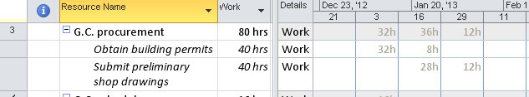

Using the timescale zoom in the lower right corner of the screen  (or double clicking on the timescale), to zoom to a per day or per week level of detail. This view may also be customized by adding columns of additional data on both the left and right sides of the view shown below.

**To add columns on the right side of the screen:**

* Right click on the right side
* Select the desired column(s) from the short list  
    
  OR
* Right click on the right side
* Select **Detail** styles
* Click on a column on the left
* Click **Show**
* With the field selected on the right, the color may be changed  
  Note: the color change is for the title rows only
* Click **OK**

While in this view, there are also buttons on the Format ribbon bar which will help customize the view. The “Add Details” is the same form as the detail styles option above. Below is a view of the Format ribbon for the Resource Usage view.

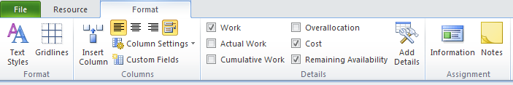

In the view below, the Remaining Availability and Cost fields have been added. The G. C. Procurement resource is assigned 80 hours to the project. He is also showing availability of 4 hours per day during the timeframe shown. The task “Obtaining building permits” is showing a 50% or 4 hours per day assignment. Using the resources standard rate, the daily costto the project will be $400.00 per day.

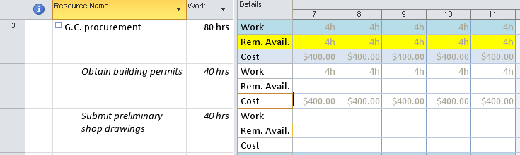

Cost rate tables are assigned to resources through the Resource Sheet using the Resource Information dialog box, Cost tab. 5 rate scales are available per resource, however only one may be used per task. The rate scales are labeled A-E and cannot be renamed. Rates will have trigger dates to enable increases to be entered in advance. Using the option outlined below allows assignment of a specific rate table to a task.

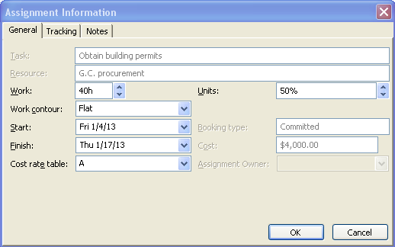

Below is an example of rate scale A applied to the task “Obtain building permits” and B has been assigned to “Submit Preliminary Shop Drawings”. The work of the first task is at a different rate than the work of the second task.

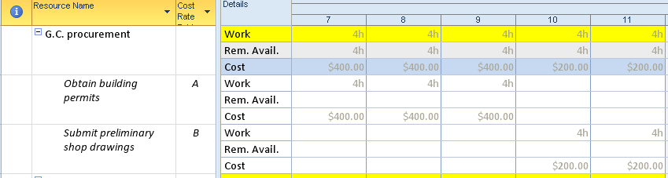

**TIP:**  *The Resource Usage view may be used for resource work distribution worksheets. When this view is printed, a timeframe maybe added to allow for more focused printing. Insert a page break between resources to print separate reports for each resource.*

In future modules we will discuss applying filters and groupings to views which will increase value of reports obtainable from this view.

## Task Usage View



Task Usage view is very similar to the Resource Usage view, however, the content is viewed from the task perspective. Each task is displayed with the resources assigned to the task. The scheduler will be able to see a complete picture of the details of assignments. This view may also be used for changing or fine tuning assignments. Details maybe viewed at any timescale density that is appropriate for your project.

Using this view will help to answer some of the following questions:

* What resources are assigned to a task?
* Which tasks are overallocated and where?
* Which tasks do not have a resource assigned?
* What are the total cost and number of hours of a task?
* What is the remaining work of a task?
* What is the Value of Baseline vs. Actual Work and Cost for a task?
* How many resources do I need to have to complete a task?
* What percent allocations are my resources assigned to tasks?

Adding column information works the same as adding information to the Resource Usage view above:

To add columns on the right side of the screen:

* Right click on the right side
* Select one of the columns from the short list  
    
  OR
* Right click on the right side
* Select “Detail styles”
* Click on a column on the left
* Click “Show”
* With the field selected on the right, the color may be changed  
  Note: the color change is for the title rows only
* Click OK

Project 2010 has provided a ribbon bar for the Task Usage view. Buttons on this bar are available to help with formatting and changing the information viewed. The Details sections will add and remove columns on the right side of the grid.

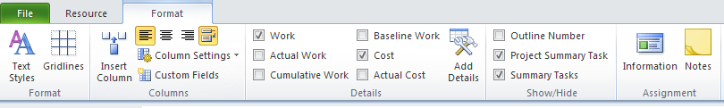

Below is an illustration of the Task Usage view showing work and cost for the “Obtain building permits” task. You will note that there are 2 resources assigned and they are not performing the same amount of the work and are working different times. They are also assigned different hourly rates.

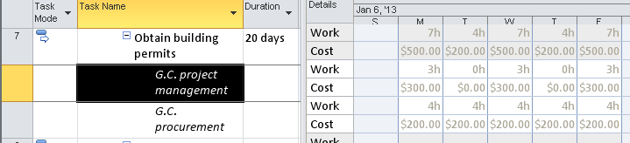

In future modules we will discuss using filters and groupings to give more dimension to the reports that can be obtained from this view.

## Team Planner View



The Team Planner view is new in Project 2010. The purpose of this view is to show resources and their assignments using a Gantt style format. The team planner view will help the scheduler identify overallocations within the schedule, level workloads, reassign resources to tasks and identify problems in the schedule from the resource point of view. This type of view is also known as Swim Lanes.

**NOTE:** *Team Planner view is only available in Project 2010 Professional.*

Team Planner view is divided into 2 sections. The upper section contains one row for each resource, with bars to the right representing assigned work. The lower section contains bars representing tasks without resources.

**To view the Team Planner:**

**Task 🡪 Gantt chart 🡪 Team Planner**

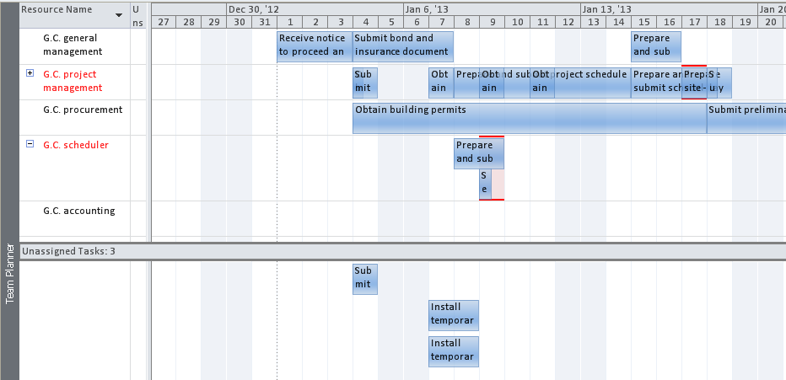

Below is a chart to help with understanding how to read the indicators of the Team Planner view:

|  |  |
| --- | --- |
| **Feature** | **Meaning** |
| A vertical orange line | Today’s date |
| Tasks colored in darker blue | Progress on the task |
| Teal colored tasks | Manually scheduled tasks |
| Gray colored tasks | External tasks |
| Light blue colored tasks | Un-started tasks |
| Gaps in timelines for resources | Under-allocated resource or unavailable |
| Red lines on the top and bottom of the task | Overallocated tasks |
| Resource name in red | Overallocated resource |
| Task bars colored black | Tasks that are late |
| Shaded day on calendar | Non-working day for the resource. This data is coming from the resource availability calendar |
| Top pane – pink blocks of time | Overallocated time |

Below are some of the keystrokes that will help you work with the information in this view.

|  |  |
| --- | --- |
| **Action** | **Result** |
| Double click the resource name | Resource Information dialog box |
| Double click a work task bar | Task Information dialog box |
| Timescale density | Adjust as needed – lower right corner |
| Hover over task | Pop up of task details |
| Double click on timescale | Opens the timescale box to alter scale values |
| Right click on a task | More options: |
| Right click on an assignment – Reassign to: | This option presents a list of all resources in the schedule, including resources already assigned to the task. Select a resource to reassign to the task or select unassigned option and all assignments will be removed from the task. |
| Right click on an assignment – Inactivate: | Task will disappear from the Team Planner view. To reactive, return to Gantt chart view. |

Things to know about when working with Team Planner view:

* Only active tasks will show in the team planner view.
* Bars may be dragged back and forth to even out workloads as well as move assignments from one resource to another.
* An unassigned task may also be moved (dragged) from the unassigned area (bottom) to a timeframe for a resource. The default assignment will be at 100% units.
* Unassigned tasks in the lower pane are aligned with their planned start dates.
* If automatic scheduling is the task mode for a task, the task type will come into play for the assignment when moved from one resource to another.
* When tasks are moved from one resource to another, assignments will be created for the new resource at the same percent allocation that the original resource was assigned.
* For automatically scheduled tasks, dragging tasks to change dates will create a *start no earlier than* constraint. This constraint might cause problems in calculating the schedule.
* Error messages will be returned when there is a relationship conflict when moving tasks.
* When moving manually scheduled tasks, all moves will be accepted and no constraints will be set.
* Tasks may be assigned to resources without being scheduled.
* A box in the upper pane represents an assignment and not a task. If a task has several resources assigned, when you move the boxes you are moving the assignment for an individual only.
* To reactivate a task, return to the Gantt view.
* Percent complete tracking will mark the tasks completed as planned. More information regarding tracking will be discussed in the tracking module.

To the right of each resource name is a column titled “Unscheduled tasks”. Unscheduled tasks may be dragged to this column to be assigned to a resource. If there is no duration value to the task, some work will be assigned to the resource. If there is a duration value on the task, the resource will be assigned at 100% and work will be calculated. Even though a work value exists for the task, the task will be considered a duration-only task.

In the example below, the task “Calculate moving expenses” is an automatically scheduled task and is not assigned to a resource.

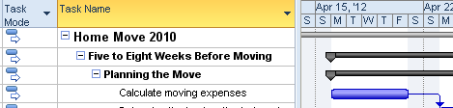

In the Team Planner view, a task is dragged from the unassigned area in the lower portion of the view to the “Unscheduled tasks” column to the right of the resource name column. The task bar changes to teal to indicate that it is a manually scheduled task. Below is the team planner view with the task reassigned but not scheduled to Bob Smith. The task is not visible in the assignment bar area of the view.

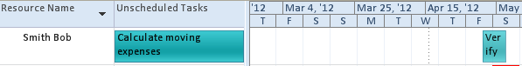

The Gantt chart for the assignment is shown below. Note the task type is manually scheduled and the Gantt bar is showing a format of unknown duration.

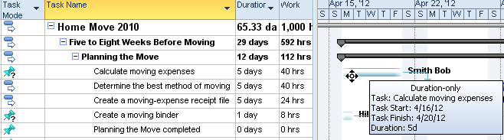

A ribbon formatting bar is available when using the Team Planner view. Tools are available for deeper formatting of this view. Show/Hide buttons add or remove data from the view.

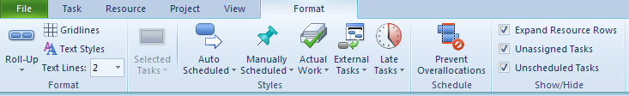

**TIP:**  *In future modules we will learn how to add buttons to the ribbon bars. A helpful addition to the Resource bar is adding the Scroll to task button.*

## Practice: Viewing Resource Assignments



*The Practice page is where you write detailed instructions for completing work listed as Exercises.*

*Type the Exercise Title and write a brief summary what the student will be doing in the exercise. Then list your ideas what they will be doing.*

*SAMPLE*

*In this practice you will create a Project Server Authentication profile and then configure the local cache settings in Project Professional 2007.*

*Exercise 1: Create Project Server Authentication Profile*

*In this exercise you will create Project Server authentication profile to connect to the Project Web Access site.*

Perform the following exercise on the PS07 virtual machine.

1. *From the* ***Start*** *menu, click* ***All Programs*** *🡪* ***Microsoft Office*** *🡪* ***Microsoft Office Tools*** *and click* ***Microsoft Office Project Server 2007 Accounts****.*
2. *In the* ***Project Server Accounts*** *dialog box, click* ***Add****.*
3. *In the* ***Account Properties*** *dialog box, and complete the following settings and click* ***OK****.*

|  |  |
| --- | --- |
| *Setting* | *Perform the following:* |
|  | |
| *Account Name* | *Type* ***Project Server*** |
| *Project Server URL* | *Type* ***http://epm/pwa*** |
| *When connecting* | *Select* ***Use Windows user account*** |
| *Set as default account* | *Select check box* |

# Lesson 5: Resolving Resource Overallocations



Most project manger’s work daily to make sure that all work is covered by appropriate resources that have enough time available to do the work necessary to complete a project. When resources are overbooked they are called Overallocated.

In this lesson we will discuss:

1. Understanding overallocations
2. Views to discover overallocations
3. Manually leveling resources
4. Automatic leveling of resources

## Understanding Overallocations



Each resource is assigned a calendar when entered on the Resource Sheet. The calendar is customized to contain the availability of the resource. When more work is assigned to a resource than time available on their resource calendar, the resource is considered to be overallocated. The overallocation calculation is looking at resource assignments on a minute by minute basis. If a resource is overbooked for even 1 minute, the resource is considered overallocated.

When a resource is overallocated, a red person symbol appears in the indicator column. This indicates that there is an overallocated resource assigned to the task but will not indicate which resource is affected. Even though resources are overallocated, assignments can continue to be created.

Below is a view of tasks with overallocated resources:

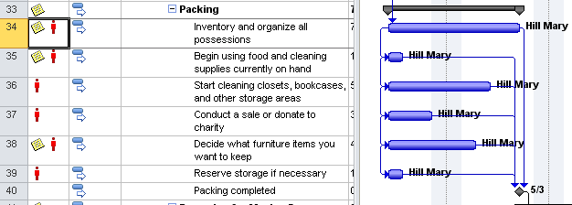

## Views to Identifying Overallocations



There are several views in Project 2010 that will help analyze resource overallocations. After an overallocation situation is discovered, research should be carried out to understand where the overallocation exists.

The views below will help locate these problems:

* Resource sheet
* Resource graph
* Resource allocation view
* Team Planner

**Resource Sheet**: shows resources that are overallocated in red and will also display a yellow warning diamond in the indicators column. This indicates that the resource is overallocated on at least one assignment.

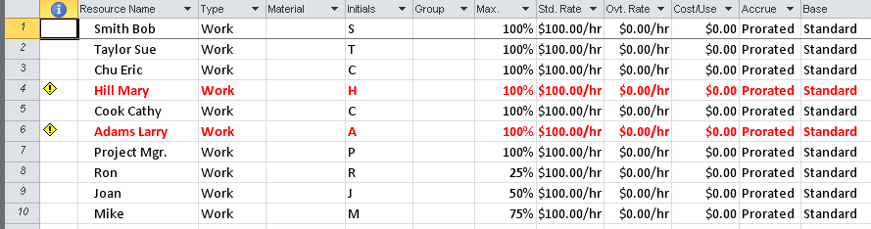

In the case of Mary Hill and Larry Adams, both are overallocated somewhere in the schedule. We will need to look at other views to get additional information.

The Resource Graph view will show what days a resource is over-allocated in a graphic format.

To view the Resource Graph:

**Task 🡪 Gantt chart 🡪 Resource Graph**

* Click the slider at the bottom of the left of the screen to scroll through the resources. Stop when a resource name is in red.
* **Resource 🡪 Next overallocation** button
* The graphic bars will advance to the first overallocated resource. Continue clicking the **Next Overallocation** button until all overallocations have been viewed. An error message will display when all overallocations are shown for a particular resource.

The view below shows Mary Hill’s 100% capacity shows an indicator line. The blue bars below the line are within her 100% capacity limits. The red bars above the line represent her overallocations based on her resource calendar. Peak Units are displayed in the lower portion of the graphic. This represents the number of resources required to accomplish the work at the current level of assignment by this resource. This example shows that we will need 600% of Mary or 6 Mary’s to complete the work.

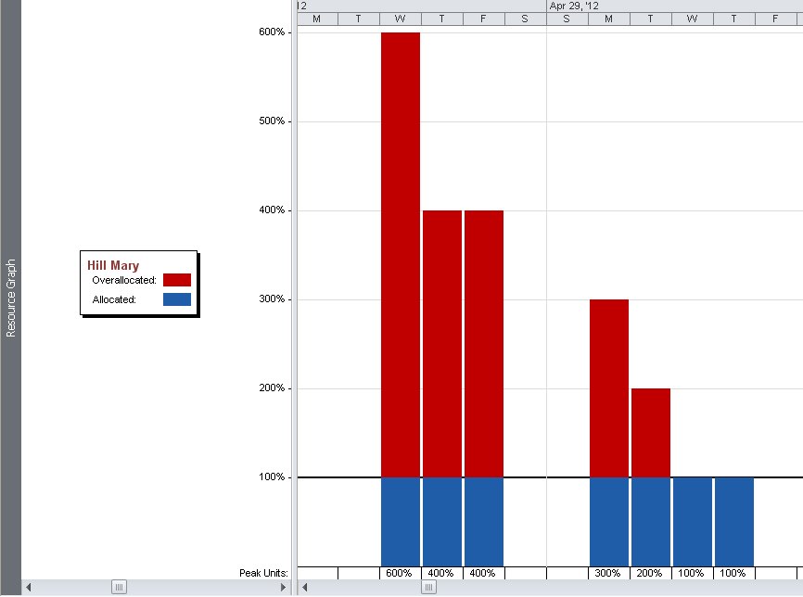

The Resource Graph view may also be customized by right clicking the Peak Units line and selecting other values to be shown on the graph. Below are the option choices for data that is available to be shown using this view. Further customization is also available using the format bar available for the Resource Graph shown below.

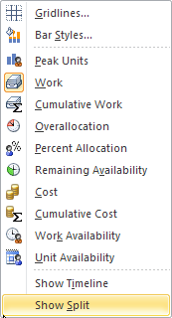

To resolve overallocations in the schedule, more information will be needed. We still need to find out more information about what tasks are involved and for how many hours. The Resource Allocation view is a split view with the Resource Usage view on the top and the Leveling Gantt view on the bottom. This view allows the scheduler to see what tasks are involved and when they are scheduled. Getting the full picture of what other tasks the resource is assigned to and who is assigned to the tasks with the resource, will give the scheduler more information to make an informed decision.

To reveal the Resource Allocation view:

* **Tasks🡪 Gantt chart 🡪 More Views 🡪 Resource Allocation view 🡪 Apply**
* Click on the overallocated resource (in red)
* Click **Scroll** **to task** button to bring Mary’s work into view

In the view below Mary is overallocated between April 25 and April 30. We can see that she is fully assigned at 100% to several tasks. Some of the tasks have a second resource assigned.

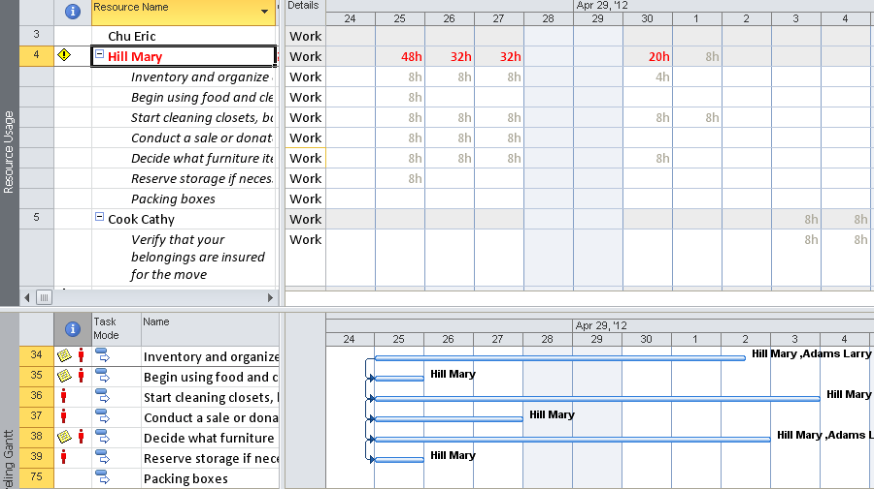

The following is the same information viewed through Team Planner:

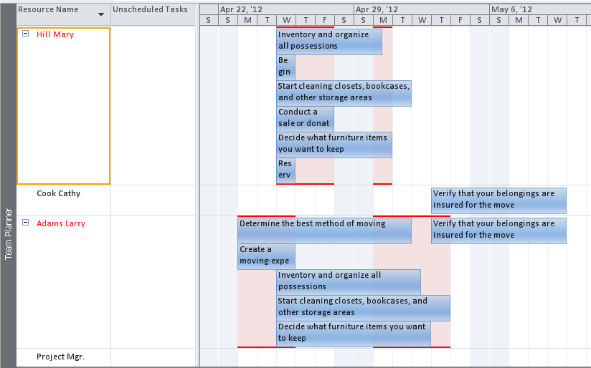

Mary’s overallocations are flagged in red with the background in pink. Multiple task assignments may be viewed simultaneously.

## Leveling Resources Manually



Project 2010 has a function called Resource Leveling that can help level the work of the resources. It is designed to move assignments forward or backward within time limits to attempt to level or smooth the workload for the resources and remove or lessen overallocations.

Automatic resource leveling in Project 2010 is designed to move resource assignments to a point in time where, based on the resource calendar, the resource has time available. If resources have a capacity of 160 hours of work available in a month and they are assigned to 200 hours of work, the project duration will extend outwards to schedule the work via resource leveling. To level resources, and keep to the original time line, either or both of the following should occur: the percentage of capacity of the resources is increased, or more resources are added. Failure to do either will result in an inability to complete some of the planned work.

Manual resource leveling should always be tried before attempting automatic leveling. Leveling is most effective when performed by a project manager who is most familiar with the work and the people.

The following are some suggestions for effective manual resource leveling:

* Add more people necessary skills to tasks
* Obtain more time from the people you already have (nights, weekends, etc)
* Outsource a portion of the work
* Negotiate deadlines to see if extensions are possible
* Move the best resources to the most critical tasks. There is less risk and greater probability of these resources completing the tasks on time.
* Give a lesser skilled resource to a highly skilled resource as an assistant. This is a win-win. The highly skilled resource will give the lesser skilled resource some of the lower level work. The lesser skilled resource will learn something new. Might increase cost.
* Cancel vacations
* Adjust relationships
* Break long tasks up into shorter tasks and divide the work over more resources if possible. Under-allocated resources will be better utilized
* Break long tasks around fixed dates. Do some of the work before and complete the work after.

## Leveling Resources Automatically



Once the decision is made that leveling needs to occur, there are several ways to level resources within the software. The different options are:

* Team planner – manually move assignments around
* Format ribbon bar – prevent overallocations
* Resource ribbon bar – level one or all resources
* Resource ribbon bar – leveling options to control how leveling occurs
* Resource ribbon bar – clear leveling

The Gantt chart below shows a summary group of automatically scheduled tasks. The tasks are all scheduled to complete on May 3. Each task has 2 assigned resources, Mary Hill and Larry Adams. They also have indicators that each of the tasks is overallocated.

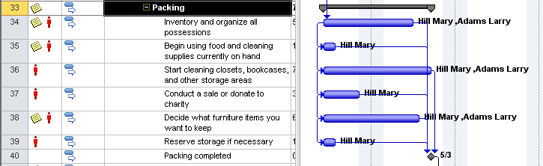

Team planner:

In the team planner view below, Mary Hill and Larry Adams are both overallocated and require leveling. Overallocated tasks are represented by displaying red lines around them.

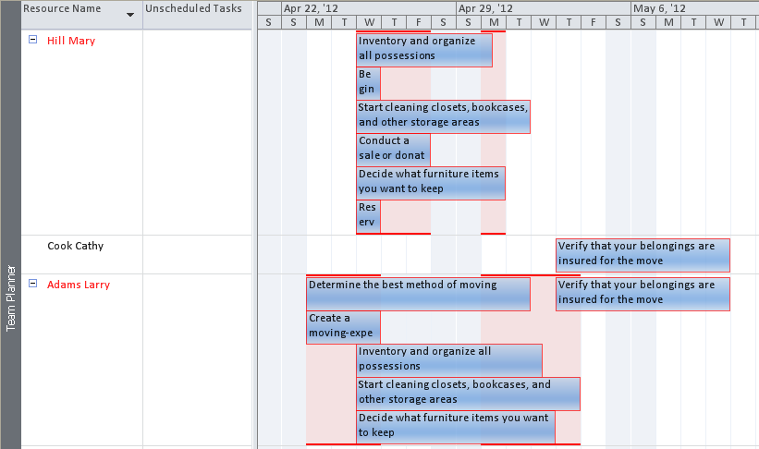

The resource ribbon bar offers several leveling options:

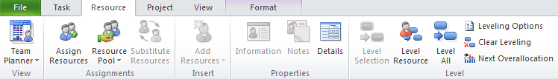

Select one resource and click **Level Selection**. The result is the selected resource will be leveled. When leveling resources from the Team Planner view, only the assignment is adjusted and not the entire task. Click **Level All** to level all tasks for the entire project.

Below is the Team Planner view with all resources leveled. Before leveling, the project was scheduled to complete on May 3rd. After leveling, the project will now complete on May 23rd.

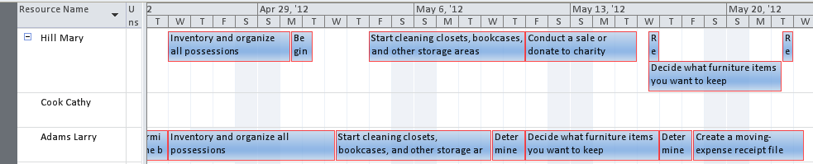

Leveling does not hurt the schedule and should be tested to see the results. Leveling can be removed at any time. To the right of the Level All button, there is a Clear leveling option.

In Team Planner view, click **Format** tab to view the Format menu bar. There is an option button labeled Prevent Overallocations. When this option is turned on, all resources will be leveled and continuously re-leveled with each task change. Additional assignments are created in other views. Returning to Team Planner view will refresh leveling.

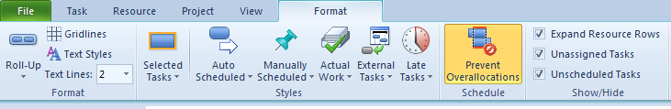

In the Team Planner allows drag and drop assignments to aid in the leveling process. Tasks may be manually move and reassigned as needed.

In the example below, the Resource Allocation view is shown with Mary Hill selected in the top pane. When leveling resources, the Resource Allocation view is effective for viewing the results of leveling.

**To display Resource Allocation view:**

Click **Task 🡪 Gantt chart 🡪 Move Views 🡪 Resource Allocation view 🡪 Apply**

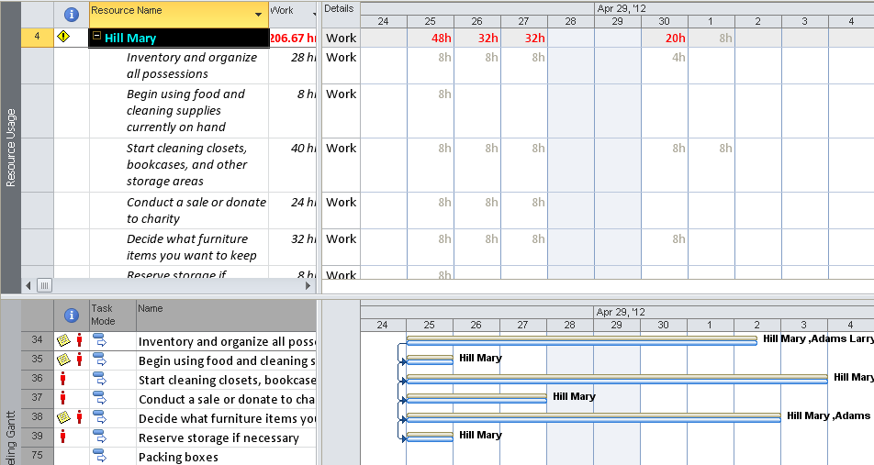

Another approach to leveling is Leveling Options on the Resource bar. When leveling the schedule using the Resource Leveling dialog box, leveling may be performed for resources, individual tasks or the entire project. After leveling is applied, the Leveling Gantt in the lower pane will display a comparison of the original schedule represented with tan bars and the result of leveling with blue bars.

**To display Resource Leveling dialog box:**

**Resource 🡪 Leveling options**

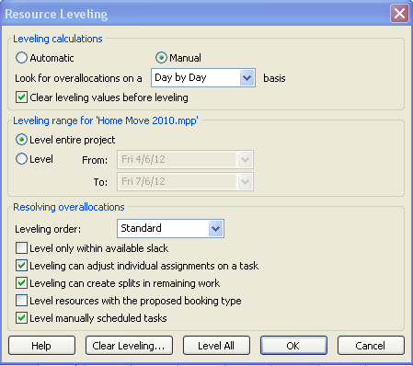

The values in the form are as follows:

* **Automatic or Manual**: the automatice option will level the schedule with each task change. For greater leveling control, Manual leveling is recommended.
* **Look for overallocations on a:** day by day is the default value. The program will attempt to make sure that all resources are not overbooked by even 1 minute during any day. Week by week allows some days to be longer and others may be shorter but the total hours for the week must match the availability calendar. Consider the length of the project when making this choice. Avery short project is better suited to the day by day option.
* **Clear leveling values before leveling:** Clears leveling from other leveling attempts.
* **Entire project or range of dates:** Start with the entire project. Smaller timeframes may be used for future leveling actions.
* **Leveling Order:**
* **ID Only:** levels tasks with higher ID number first.
* **Standard:** uses task duration, dependencies, slack, task dates, constraints, tasks without successors and priorities to level the tasks.
* **Priority Standard:** all tasks and projects have a priority setting of 1-1000 with 1000 being the highest. This leveling option, awards priority to the higher priority value tasks and those tasks are considered first during leveling.
* **Level within available slack:** locks the project end date and all tasks will be leveled within the current time period.
* **Leveling can adjust individual assignments on a task:** leveling will never remove or replace a resource on a task. This option refers to the concept of keeping all resources together on the task or can they perform their work individually. This option is being set for the entire schedule which might not be the case. There is a field on each task that will control this option called Level Assignments. To make this a task level value, insert the column Level Assignments and set the value for individual tasks.
* **Leveling can create splits in remaining work:** allows the remaining work of a task to be split. This option can be controlled at the individual task level using the task field Leveling Can Split.
* **Resources with Proposed booking types:**  affects Project Server 2010 users only. Should planned, but uncomitted resources for the project, be included in the leveling process?
* **Level manually scheduled tasks**: includes manually scheduled tasks when leveling.

Below is a view of the post leveled tasks. Note the tan bars showing what the schedule looked like before the leveling and the blue bars representating the after status. The ending date is far beyond the original scheduled date. By dragging the split bar up to the top of the screen, the Resource Usage view will disappear and the entire view will be the Leveling Gantt. This view will show the affect of leveling for the entire project.

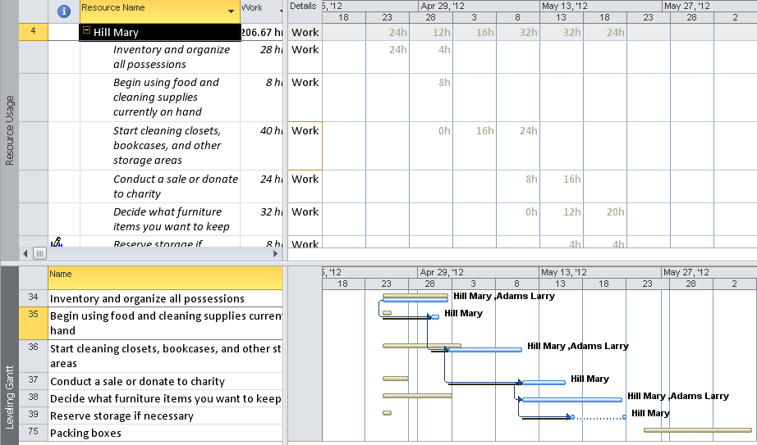

## Practice: Resolving Resource Overallocations



*The Practice page is where you write detailed instructions for completing work listed as Exercises.*

*Type the Exercise Title and write a brief summary what the student will be doing in the exercise. Then list your ideas what they will be doing.*

*SAMPLE*

*In this practice you will create a Project Server Authentication profile and then configure the local cache settings in Project Professional 2007.*

*Exercise 1: Create Project Server Authentication Profile*

*In this exercise you will create Project Server authentication profile to connect to the Project Web Access site.*

Perform the following exercise on the PS07 virtual machine.

1. *From the* ***Start*** *menu, click* ***All Programs*** *🡪* ***Microsoft Office*** *🡪* ***Microsoft Office Tools*** *and click* ***Microsoft Office Project Server 2007 Accounts****.*
2. *In the* ***Project Server Accounts*** *dialog box, click* ***Add****.*
3. *In the* ***Account Properties*** *dialog box, and complete the following settings and click* ***OK****.*

|  |  |
| --- | --- |
| *Setting* | *Perform the following:* |
|  | |
| *Account Name* | *Type* ***Project Server*** |
| *Project Server URL* | *Type* ***http://epm/pwa*** |
| *When connecting* | *Select* ***Use Windows user account*** |
| *Set as default account* | *Select check box* |

# Summary



The creation of resource work assignments takes practice. It is important because assignments are the basis for project scheduling, costing and resource allocations. Determine the types of assignments that will make your schedule most successful. Knowing your goals will help simplify the scheduling process.

In this module you learned:

1. Concepts behind resource assignments
2. Scheduling formulas
3. Creating assignments for work resources
4. Views in Project 2010 used to see assignments
5. Leveling the work of resource assignments